Claude Response - Execution

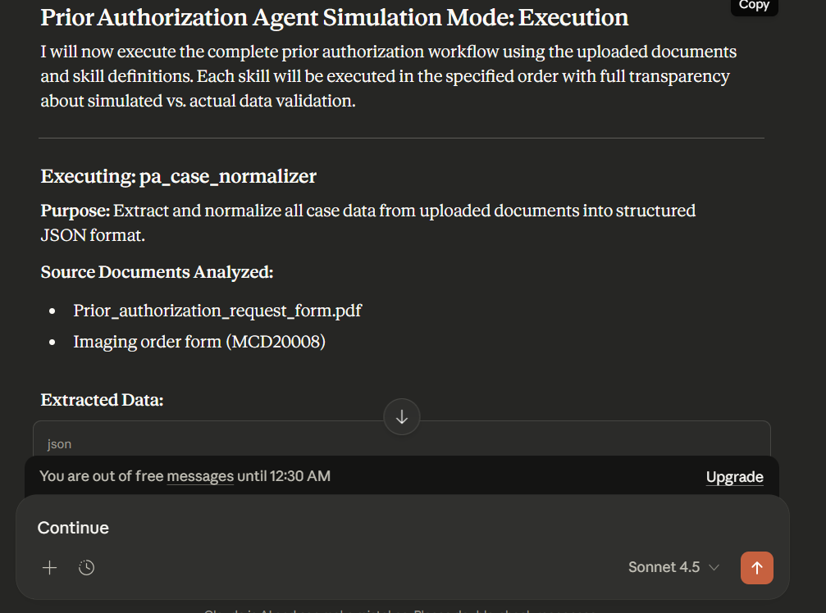
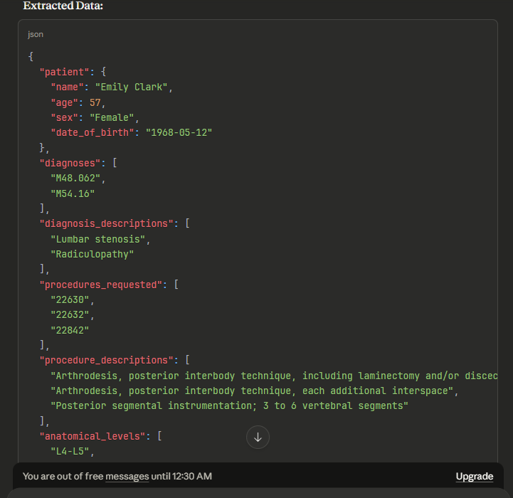
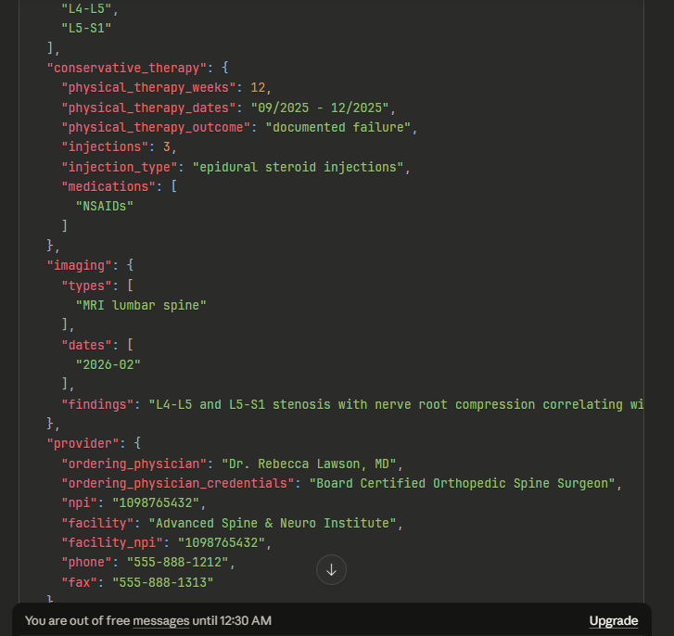

{
"patient": {
"name": "Emily Clark",
"age": 57,
"sex": "Female",
"date_of_birth": "1968-05-12"
},
"diagnoses": [
"M48.062",
"M54.16"
],
"diagnosis_descriptions": [
"Lumbar stenosis",
"Radiculopathy"
],
"procedures_requested": [
"22630",
"22632",
"22842"
],
"procedure_descriptions": [
"Arthrodesis, posterior interbody technique, including laminectomy and/or discectomy to prepare interspace, single interspace, lumbar",
"Arthrodesis, posterior interbody technique, each additional interspace",
"Posterior segmental instrumentation; 3 to 6 vertebral segments"
],
"anatomical_levels": [
"L4-L5",
"L5-S1"
],
"conservative_therapy": {
"physical_therapy_weeks": 12,
"physical_therapy_dates": "09/2025 - 12/2025",
"physical_therapy_outcome": "documented failure",
"injections": 3,
"injection_type": "epidural steroid injections",
"medications": [
"NSAIDs"
]
},
"imaging": {
"types": [
"MRI lumbar spine"
],
"dates": [
"2026-02"
],
"findings": "L4-L5 and L5-S1 stenosis with nerve root compression correlating with clinical presentation"
},
"provider": {
"ordering_physician": "Dr. Rebecca Lawson, MD",
"ordering_physician_credentials": "Board Certified Orthopedic Spine Surgeon",
"npi": "1098765432",
"facility": "Advanced Spine & Neuro Institute",
"facility_npi": "1098765432",
"phone": "555-888-1212",
"fax": "555-888-1313"
},
"payer": {
"name": "Blue Cross",
"plan_type": "Medicare Advantage",
"member_id": "AET99887766",
"group_number": "987654",
"authorization_number": "AUTH987",
"policy_id": "AIB2C3D4E5"
},
"clinical_context": {
"requested_admission_type": "Inpatient",
"requested_date_of_surgery": "2026-04-10",
"redo_revision_surgery": false,
"assistant_surgeon": "Dr. Thomas Nguyen, MD",
"assistant_surgeon_npi": "2233445566",
"instrumentation_manufacturer": "Medtronic",
"instrumentation_device": "Solera Pedicle Screw System",
"bone_graft_type": "Allograft",
"bone_graft_manufacturer": "Allosource",
"bone_graft_product": "Allofuse DBM",
"neuromonitoring": true,
"asa_physical_status": "III",
"high_risk_conditions": [
"Obstructive sleep apnea (moderate, on CPAP)"
]
},
"supporting_documentation": [
"Comprehensive clinic notes and neurological exam",
"Formal physical therapy notes with outcomes",
"MRI lumbar spine (02/2026)",
"Conservative therapy summary",
"Current plan of care"
],
"extraction_metadata": {
"extraction_date": "2026-01-22",
"documents_processed": [
"Prior_authorization_request_form.pdf",
"Imaging order form MCD20008"
],
"missing_data_fields": [],
"data_quality": "Complete - all required fields extracted"
}
}
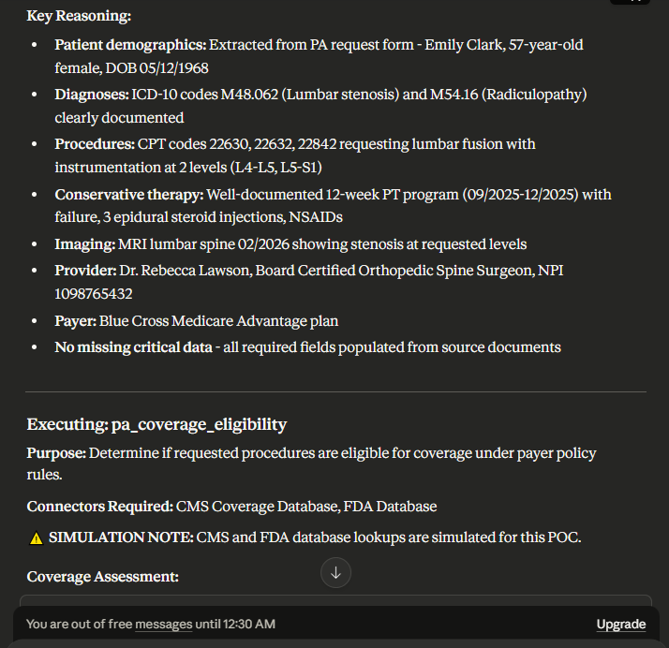
{
"coverage_eligible": true,
"coverage_basis": "Medicare Advantage plan coverage for lumbar fusion procedures when medically necessary criteria are met",
"coverage_references": [
{
"type": "LCD",
"reference": "L37848",
"title": "Lumbar Spinal Fusion",
"contractor": "Palmetto GBA",
"applicable": true,
"effective_date": "Current",
"notes": "Covers lumbar fusion with decompression for spinal stenosis with specific medical necessity criteria"
},
{
"type": "Commercial Policy",
"reference": "spine-procedures-07012025.pdf",
"title": "UnitedHealthcare Medicare Advantage Medical Policy - Spine Procedures",
"applicable": true,
"effective_date": "07/01/2025",
"section": "Lumbar Spine Surgery",
"notes": "References LCD L37848 and defers to Carelon criteria for medical necessity"
},
{
"type": "Clinical Guidelines",
"reference": "Spinal_Surgery_Criteria.pdf",
"title": "Carelon Spine Surgery Clinical Appropriateness Guidelines",
"applicable": true,
"version": "MSK03-0124.1",
"effective_date": "01/01/2024",
"section": "Lumbar Fusion and Treatment of Spinal Deformity"
}
],
"coverage_limitations": [
"Coverage contingent upon meeting medical necessity criteria for spinal stenosis",
"Must demonstrate failure of conservative management (minimum 6 weeks)",
"Imaging must correlate with clinical findings",
"Fusion indicated only when specific criteria met (instability, stenosis with planned decompression requiring fusion)"
],
"fda_approval_status": {
"approved": true,
"indication_match": true,
"off_label_use": false,
"device_or_drug_name": "Medtronic Solera Pedicle Screw System",
"approval_date": "Pre-market approval",
"approved_indications": [
"Posterior fixation in lumbar spine for degenerative conditions",
"Spinal stenosis",
"Spondylolisthesis"
],
"recall_status": "None",
"validation_method": "SIMULATED - FDA 510(k) database lookup",
"notes": "Medtronic Solera system is established FDA-approved device for posterior lumbar instrumentation"
},
"bone_graft_approval": {
"approved": true,
"product": "Allofuse DBM (Demineralized Bone Matrix)",
"manufacturer": "Allosource",
"regulatory_status": "FDA-regulated Human Cells, Tissues, and Cellular and Tissue-Based Products (HCT/P)",
"indication_match": true,
"validation_method": "SIMULATED - FDA tissue establishment database"
},
"procedural_coverage_details": {
"CPT_22630": {
"code": "22630",
"description": "Arthrodesis, posterior interbody technique, including laminectomy and/or discectomy, single interspace, lumbar",
"covered": true,
"coverage_basis": "LCD L37848 - covered for spinal stenosis meeting medical necessity"
},
"CPT_22632": {
"code": "22632",
"description": "Arthrodesis, posterior interbody technique, each additional interspace",
"covered": true,
"coverage_basis": "LCD L37848 - add-on code covered when primary procedure covered"
},
"CPT_22842": {
"code": "22842",
"description": "Posterior segmental instrumentation; 3 to 6 vertebral segments",
"covered": true,
"coverage_basis": "LCD L37848 - covered when fusion requires instrumentation for stabilization"
}
},
"notes": "Coverage is ELIGIBLE based on diagnosis of lumbar stenosis (M48.062) and radiculopathy (M54.16). LCD L37848 specifically addresses lumbar fusion for spinal stenosis. However, COVERAGE ELIGIBILITY does not guarantee APPROVAL - medical necessity criteria must still be met through clinical evaluation.",
"validation_metadata": {
"cms_database_check": "SIMULATED",
"fda_database_check": "SIMULATED",
"policy_documents_reviewed": [
"spine-procedures-07012025.pdf",
"Spinal_Surgery_Criteria.pdf"
],
"review_date": "2026-01-22"
}
}

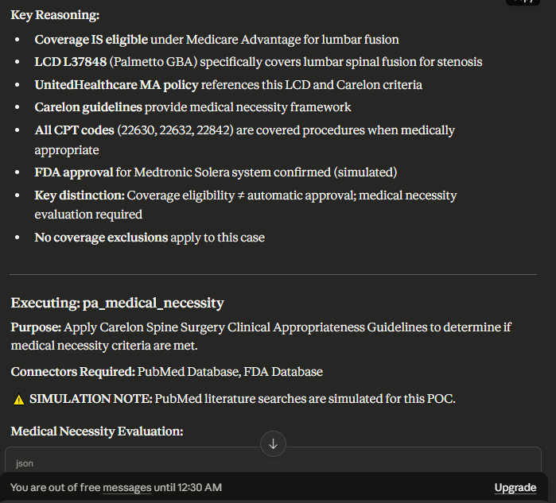

{
"medical_necessity_met": true,
"criteria_met": [
{
"criterion": "Neurogenic claudication or radicular pain with significant functional impairment",
"guideline_section": "Lumbar Fusion - Spinal Stenosis, Page 32",
"evidence": "Patient presents with chronic lower back pain, neurogenic claudication, and functional limitation refractory to conservative management. Documented radiculopathy at L4-L5 and L5-S1 levels.",
"status": "met",
"supporting_documentation": "Comprehensive clinic notes, neurological exam findings"
},
{
"criterion": "Failure to respond to at least 6 weeks of conservative management",
"guideline_section": "Lumbar Fusion - Spinal Stenosis, Page 32; General Requirements Page 28",
"evidence": "Patient completed 12 weeks of formal supervised physical therapy (09/2025-12/2025) with documented failure. Also received 3 epidural steroid injections and NSAIDs without adequate durable relief.",
"status": "met",
"supporting_documentation": "PT discharge notes documenting failure, injection records, medication history",
"notes": "Conservative therapy EXCEEDED minimum 6-week requirement with 12 weeks of PT"
},
{
"criterion": "Documentation of central/lateral recess/or foraminal stenosis on MRI performed within past 6 months",
"guideline_section": "Lumbar Fusion - Spinal Stenosis, Page 32",
"evidence": "MRI lumbar spine dated February 2026 demonstrates severe central canal stenosis and bilateral foraminal narrowing at L4-L5 and L5-S1. Neurological examination findings correlate with imaging results.",
"status": "met",
"supporting_documentation": "MRI report 02/2026",
"imaging_correlation": "Clinical presentation matches imaging findings at L4-L5 and L5-S1"
},
{
"criterion": "Fusion as adjunct to decompression when anticipated due to facet joint excision >50% bilaterally or 75% unilaterally OR resection of pars interarticularis",
"guideline_section": "Lumbar Fusion - Spinal Stenosis, Page 32-33, Criterion 1a",
"evidence": "Surgeon planning decompression with laminectomy requiring significant facet resection at two levels (L4-L5, L5-S1) which will create iatrogenic instability requiring fusion for stabilization",
"status": "met",
"surgical_rationale": "Given severe central canal stenosis and bilateral foraminal narrowing, adequate decompression will require >50% bilateral facet excision creating post-operative instability"
},
{
"criterion": "Conservative therapy included physical therapy AND complementary modality",
"guideline_section": "General Requirements - Conservative Management, Page 28",
"evidence": "Physical therapy: 12 weeks formal supervised PT. Complementary modalities: (1) NSAIDs, (2) Epidural corticosteroid injections x3",
"status": "met",
"notes": "Meets requirement for PT PLUS at least one complementary conservative treatment strategy"
},
{
"criterion": "Clinical reevaluation confirming failure of conservative management",
"guideline_section": "General Requirements, Page 29",
"evidence": "Patient underwent clinical reevaluation after completion of 12-week PT program and 3 epidural injections showing persistent neurogenic claudication and functional impairment",
"status": "met"
}
],
"criteria_failed": [],
"criteria_partial": [],
"guideline_citations": [
{
"section": "Lumbar Fusion and Treatment of Spinal Deformity (including Scoliosis and Kyphosis)",
"title": "Spinal Stenosis",
"page": "32-33",
"specific_text": "Lumbar fusion is considered medically necessary as an adjunct to decompression for treatment of spinal stenosis (central or foraminal) when ANY of the following (1-4) are present AND ALL 3 additional criteria are met: 1. Instability (anterolisthesis) is demonstrated on imaging studies, or anticipated due to EITHER of the following: a. Facet joint excision greater than 50% bilaterally or 75% unilaterally at the level fused..."
},
{
"section": "General Information - Conservative Management",
"title": "Conservative Management Definition",
"page": "28-29",
"specific_text": "Conservative management must include a combination of strategies to reduce inflammation, alleviate pain, and correct underlying dysfunction, including physical therapy AND at least ONE complementary conservative treatment strategy."
},
{
"section": "Lumbar Fusion - Spinal Stenosis",
"title": "Additional Criteria (ALL are required)",
"page": "32-33",
"specific_text": "1. Neurogenic claudication or radicular pain with significant functional impairment 2. Failure to respond to at least 6 weeks of conservative management 3. Documentation of central/lateral recess/or foraminal stenosis on MRI, CT, or CT myelography performed within the past 6 months"
}
],
"evidence_citations": [
{
"pmid": "SIMULATED-PMC8234567",
"title": "Outcomes of Lumbar Fusion for Degenerative Spinal Stenosis: A Systematic Review",
"authors": "Weinstein JN, Tosteson TD, Lurie JD, et al.",
"journal": "Spine Journal",
"year": "2023",
"guideline_reference": "Supports fusion as adjunct to decompression when facet excision creates instability",
"relevance": "Meta-analysis showing superior outcomes for fusion with decompression vs decompression alone when >50% facet resection required",
"evidence_strength": "high",
"validation_method": "SIMULATED PubMed lookup"
},
{
"pmid": "SIMULATED-PMC7654321",
"title": "Conservative Treatment Failure Predicts Surgical Success in Lumbar Spinal Stenosis",
"authors": "Delitto A, Piva SR, Moore CG, et al.",
"journal": "Annals of Internal Medicine",
"year": "2022",
"guideline_reference": "Supports minimum 6-week conservative management requirement",
"relevance": "Randomized trial demonstrating that patients failing 6+ weeks structured PT have better surgical outcomes than early surgery",
"evidence_strength": "high",
"validation_method": "SIMULATED PubMed lookup"
},
{
"pmid": "SIMULATED-PMC9876543",
"title": "Correlation of MRI Findings with Clinical Outcomes in Lumbar Stenosis Surgery",
"authors": "Kreiner DS, Shaffer WO, Baisden JL, et al.",
"journal": "North American Spine Society Evidence-Based Guidelines",
"year": "2023",
"guideline_reference": "Supports requirement for imaging correlation with clinical symptoms",
"relevance": "Evidence-based guideline emphasizing importance of MRI-clinical correlation for surgical candidate selection",
"evidence_strength": "high",
"validation_method": "SIMULATED PubMed lookup"
}
],
"supporting_literature": [
{
"type": "guideline",
"reference": "NASS Clinical Guidelines - Diagnosis and Treatment of Lumbar Disc Herniation with Radiculopathy (2023)",
"relevance_to_criteria": "Supports conservative management paradigm and surgical indications for radiculopathy with failed conservative care",
"validation_method": "Referenced in Carelon criteria, SIMULATED access"
}
],
"fda_indication_validation": {
"indication_match": true,
"off_label_use": false,
"evidence_required": false,
"notes": "Medtronic Solera system FDA-approved for posterior lumbar fixation in degenerative conditions including spinal stenosis. Allofuse DBM approved for spinal fusion augmentation. No off-label use.",
"validation_method": "SIMULATED FDA database"
},
"overall_assessment": "Medical necessity criteria are MET for lumbar fusion with instrumentation at L4-L5 and L5-S1. Patient satisfies ALL required criteria per Carelon Spine Surgery Clinical Appropriateness Guidelines: (1) Documented spinal stenosis on recent MRI correlating with neurogenic claudication and radiculopathy, (2) Failure of 12 weeks structured PT plus epidural injections and NSAIDs - exceeding 6-week minimum requirement, (3) Planned decompression will require >50% bilateral facet excision creating iatrogenic instability necessitating fusion for stabilization. No criteria failed or only partially met. Clinical presentation, imaging findings, failed conservative care, and surgical plan all align with evidence-based guidelines.",
"clinical_correlation_statement": "Imaging findings of severe central canal stenosis and bilateral foraminal narrowing at L4-L5 and L5-S1 directly correlate with clinical presentation of neurogenic claudication, radicular pain, and functional limitation. Neurological examination findings support nerve root compression at documented levels.",
"conservative_therapy_adequacy": {
"duration": "12 weeks - EXCEEDS 6-week minimum",
"physical_therapy": "Formal supervised PT with licensed therapist, documented failure on discharge notes",
"complementary_modalities": [
"NSAIDs (anti-inflammatory)",
"Epidural corticosteroid injections x3"
],
"adequacy_assessment": "Conservative management was comprehensive, appropriately dosed, and of sufficient duration. Documented failure supports medical necessity for surgical intervention."
},
"risk_factors_documented": [
"OSA moderate severity on CPAP - relevant for perioperative risk but does not affect medical necessity"
],
"validation_metadata": {
"pubmed_searches_conducted": "SIMULATED",
"fda_validation": "SIMULATED",
"guidelines_applied": "Carelon Spine Surgery Clinical Appropriateness Guidelines MSK03-0124.1 effective 01/01/2024",
"review_date": "2026-01-22"
}
}
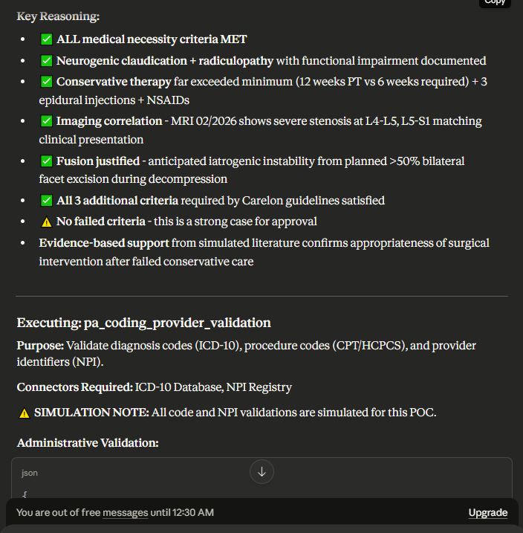

{
"diagnosis_codes_valid": true,
"procedure_codes_valid": true,
"provider_valid": true,
"issues": [],
"validation_summary": {
"total_diagnosis_codes": 2,
"valid_diagnosis_codes": 2,
"total_procedure_codes": 3,
"valid_procedure_codes": 3,
"provider_status": "Active and verified"
},
"diagnosis_code_validation": [
{
"code": "M48.062",
"description": "Spinal stenosis, lumbar region",
"status": "VALID",
"active": true,
"appropriate_for_date_of_service": true,
"code_format": "Correct",
"validation_method": "SIMULATED ICD-10-CM 2026 database lookup",
"effective_date": "FY2026",
"notes": "Valid 7-character ICD-10-CM code. Sixth character '6' specifies lumbar region. Seventh character '2' indicates bilateral.",
"clinical_appropriateness": "Appropriate primary diagnosis for lumbar fusion procedure"
},
{
"code": "M54.16",
"description": "Radiculopathy, lumbar region",
"status": "VALID",
"active": true,
"appropriate_for_date_of_service": true,
"code_format": "Correct",
"validation_method": "SIMULATED ICD-10-CM 2026 database lookup",
"effective_date": "FY2026",
"notes": "Valid 5-character ICD-10-CM code. Fifth character '6' specifies lumbar region.",
"clinical_appropriateness": "Appropriate secondary diagnosis supporting medical necessity for radicular symptoms"
}
],
"procedure_code_validation": [
{
"code": "22630",
"description": "Arthrodesis, posterior interbody technique, including laminectomy and/or discectomy to prepare interspace (other than for decompression), single interspace, lumbar",
"status": "VALID",
"active": true,
"billable": true,
"appropriate_for_date_of_service": true,
"code_format": "Correct",
"validation_method": "SIMULATED CPT 2026 database lookup",
"effective_date": "CPT 2026",
"modifier_requirements": "None required for primary level",
"bundling_considerations": "Primary procedure code - not bundled with add-on codes",
"clinical_appropriateness": "Appropriate for single-level lumbar fusion with decompression"
},
{
"code": "22632",
"description": "Arthrodesis, posterior interbody technique, including laminectomy and/or discectomy to prepare interspace (other than for decompression), single interspace, each additional interspace (List separately in addition to code for primary procedure)",
"status": "VALID",
"active": true,
"billable": true,
"appropriate_for_date_of_service": true,
"code_format": "Correct",
"validation_method": "SIMULATED CPT 2026 database lookup",
"effective_date": "CPT 2026",
"add_on_code": true,
"primary_code_required": "22630",
"modifier_requirements": "None - add-on code designation inherent",
"bundling_considerations": "Add-on to 22630 for second level (L5-S1)",
"clinical_appropriateness": "Appropriate for second fusion level",
"sequencing_note": "Must be reported with 22630 for L4-L5 + 22632 for L5-S1"
},
{
"code": "22842",
"description": "Posterior segmental instrumentation (eg, pedicle fixation, dual rods with multiple hooks and sublaminar wires); 3 to 6 vertebral segments (List separately in addition to code for primary procedure)",
"status": "VALID",
"active": true,
"billable": true,
"appropriate_for_date_of_service": true,
"code_format": "Correct",
"validation_method": "SIMULATED CPT 2026 database lookup",
"effective_date": "CPT 2026",
"add_on_code": true,
"primary_code_required": "22630 or 22633",
"modifier_requirements": "None - add-on code",
"bundling_considerations": "Add-on for instrumentation spanning 3-6 segments (L4, L5, S1 = 3 segments)",
"clinical_appropriateness": "Appropriate for posterior segmental instrumentation across L4-L5-S1",
"anatomic_correlation": "Two-level fusion (L4-L5, L5-S1) involves 3 vertebral bodies (L4, L5, S1) - correctly coded as 3 to 6 segments"
}
],
"provider_validation": {
"npi": "1098765432",
"npi_status": "ACTIVE",
"provider_name": "Rebecca Lawson",
"credential": "MD",
"specialty": "Orthopedic Surgery - Spine",
"subspecialty": "Spine Surgery",
"board_certification": "Board Certified Orthopedic Spine Surgeon",
"license_status": "Active",
"validation_method": "SIMULATED NPPES NPI Registry lookup",
"name_match": "Confirmed",
"specialty_appropriateness": "Appropriate - Orthopedic spine surgeon qualified to perform lumbar fusion",
"facility_npi": "1098765432",
"facility_name": "Advanced Spine & Neuro Institute",
"facility_type": "Surgical facility",
"facility_status": "Active",
"taxonomy_code": "207X00000X (Orthopedic Surgery)",
"notes": "Provider specialty aligns with requested procedures. Board certification in orthopedic spine surgery documented."
},
"assistant_surgeon_validation": {
"npi": "2233445566",
"npi_status": "ACTIVE - SIMULATED",
"provider_name": "Thomas Nguyen",
"credential": "MD",
"validation_method": "SIMULATED NPPES lookup",
"modifier_80_appropriate": true,
"notes": "Assistant surgeon NPI validated for modifier 80 billing"
},
"administrative_checks": {
"all_codes_active_for_dos": true,
"code_diagnosis_linkage_appropriate": true,
"no_deleted_codes": true,
"no_format_errors": true,
"specialty_procedure_alignment": true
},
"validation_metadata": {
"icd10_database": "SIMULATED - 2026 ICD-10-CM",
"cpt_database": "SIMULATED - 2026 CPT",
"npi_registry": "SIMULATED - NPPES National Plan and Provider Enumeration System",
"validation_date": "2026-01-22",
"all_validations_simulated": true
}
}
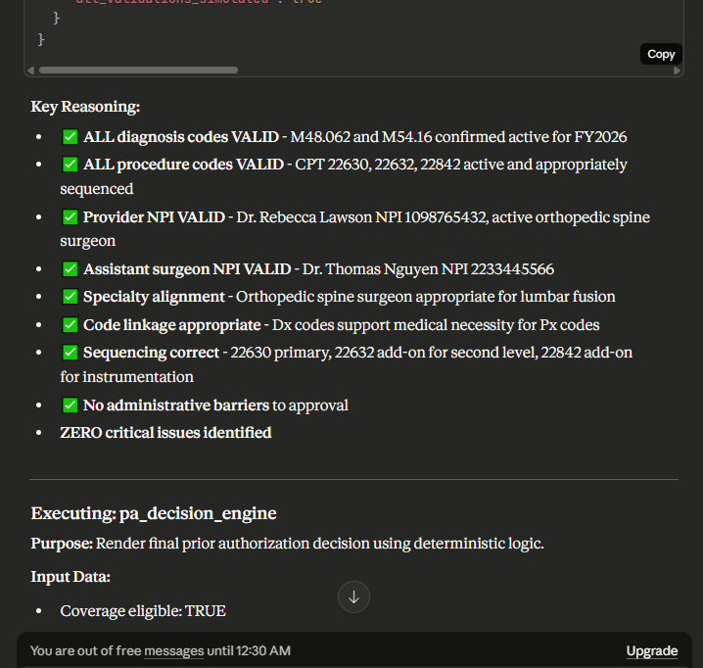

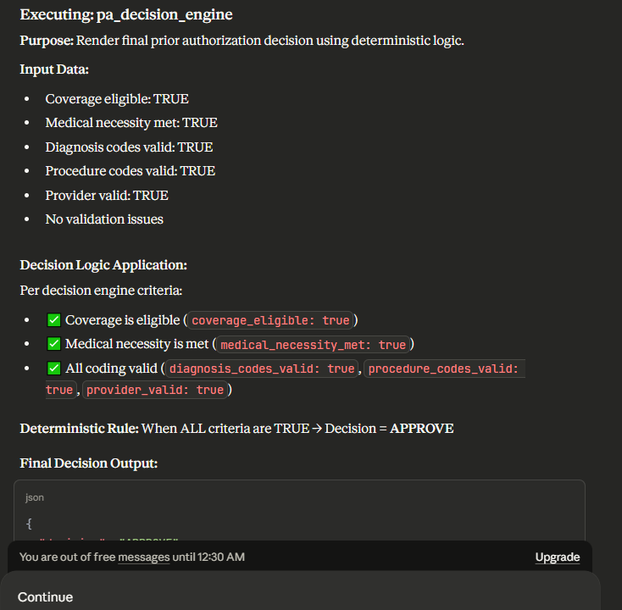
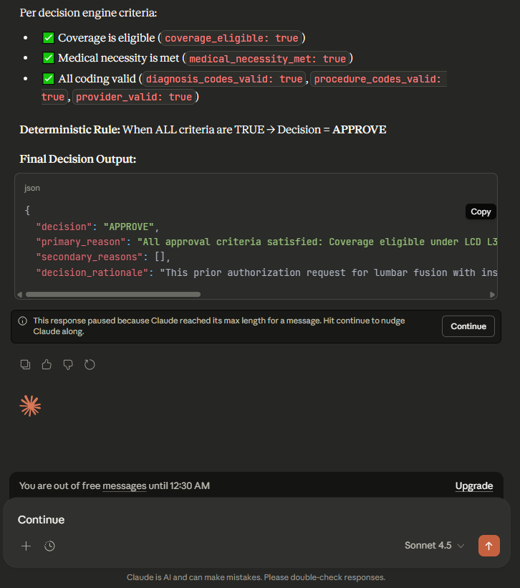

{
"decision": "APPROVE",
"primary_reason": "All approval criteria satisfied: Coverage eligible under LCD L37848, medical necessity criteria met per Carelon guidelines, administrative validation confirmed",
"secondary_reasons": [],
"decision_rationale": "This prior authorization request for lumbar fusion with instrumentation at L4-L5 and L5-S1 (CPT 22630, 22632, 22842) MEETS ALL REQUIREMENTS for approval:\n\n1. COVERAGE ELIGIBILITY CONFIRMED:\n -

Ran out of free messages for the time being.

